121 Red Arrows Accelerated Training Program
For Advancement to Level Two

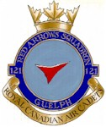

PO 103 – PARTICIPATE AS A MEMBER OF A TEAM

M103.01 – Identify the Responsibilities of a Follower in a Team.
OBJECTIVES
By the end of this lesson the cadet shall be expected to identify the responsibilities of a follower in a team.
IMPORTANCE
Cadets need to learn how to be effective members of a team. Understanding the responsibilities of a follower in a team setting will make cadets more aware of what is expected of them. This knowledge will enable them to contribute to the overall success of the team.

TEACHING POINTS

RESPECT THE LEADER AND OTHER TEAM MEMBERS
The ability to work with other people in a team is a useful skill. A sincere respect for other people is a great asset. In order to be an effective team member one must respect what the leader is asking the team to do. It is also important to respect the opinion and views of the other members of the team.

COOPERATE WITH OTHERS
In order for the team to effectively and efficiently achieve an objective the members must cooperate. Through cooperation a great deal more can be achieved than by working alone.

ADMIT MISTAKES AND LEARN FROM EXPERIENCE
In a team setting one must be able to admit when they are wrong and learn from the mistake. This will make the team stronger and create a better outcome.

ACCEPT CONSTRUCTIVE CRITICISM
Constructive criticism is observations or thoughts about ways to improve the manner in which a task was completed. Leaders will often provide constructive criticism to members of the team. This criticism is given to assist individuals develop as team member and eventually become leaders. Members must learn to take this criticism and use it in a beneficial way.

ASSUME RESPONSIBILITY
Team members should be prepared to assume responsibility when needed. The team leader will often delegate duties to team members and rely on these members to be prepared and willing to take on the responsibility.

BE HONEST
Team members must be honest with others in the team. Most people will believe and want to work with someone they trust. Honesty is an important characteristic of a good follower. In order to complete objectives, team members must trust each other and be honest.

ACCEPT OTHER TEAM MEMBERS FOR WHO THEY ARE
It is important to be sensitive to other people’s wants and needs and to changes in these wants and needs. Acceptance and understanding of individual differences will allow the group to communicate and cooperate.

KNOW THE JOB AND BE PREPARED
A good follower needs to be knowledgeable about the group’s goals. An effective follower should be organized and prepared.

COMMUNICATE CLEARLY WITH OTHERS
A follower must be able to understand and communicate with the leader and other team members.
Communication works in two directions, listening and speaking. The ability to listen to others is essential in receiving correct information and implementing the strategy outlined for the team.

PO 104 – DEVELOP A PERSONAL ACTIVITY PLAN

M104.01- IDENTIFY ACTIVITIES THAT WILL HELP ACHIEVE A HEALTHY ACTIVE
OBJECTIVES
By the end of this lesson the cadet shall be expected to identify activities that will help them achieve a healthy and active lifestyle.

IMPORTANCE
Physical fitness is one of the three aims of the cadet program. Teaching the cadets what activities contribute to an active lifestyle will help them achieve physical fitness.

TEACHING POINTS

CANADA’S PHYSICAL ACTIVITY GUIDE TO HEALTHY ACTIVE LIVING
Hand out Canada’s Physical Activity Guide to Healthy Active Living, highlighting the following pages and information detailed there:

Page 4 – Check Out What You Are Doing Now. Is your exercise time more than 90 minutes per day? Less than 90 minutes but more than 60? Less than 60 but more than 30? Have each cadet write down their activities from yesterday and two days ago to add up their total time.

Page 5 – Benefits of Physical Activity. Meet new friends, improve physical self-esteem, achieve a
healthy weight, build strong bones and strengthen muscles, maintain flexibility, promote good posture and balance, improve fitness, strengthen the heart, increase relaxation and promote healthy growth and development.

Page 6 – What Are You Into. Walking, running, hiking, cycling, swimming, jogging, gymnastics, iceskating, skiing, basketball, volleyball, tobogganing, soccer, football, tennis, baseball, softball, dancing, yoga, climbing, bowling, hockey, skateboarding, badminton, etc. Have the cadets brainstorm all the activities they can think of that they may be interested in.

Page 8 – Let’s Get Active. Increase the time currently spent on physical activity and reduce non-active time.

Page 10 – Crank Up Your Activity. Walking instead of taking the bus, playing ball at breaks, walking the dog, raking leaves, shovelling snow, carrying groceries, etc. Brainstorm ideas that will help increase current physical activity.
The purpose of highlighting these pages is to fuel the discussion for the next teaching point. The cadets may take home the guides and explore them further afterwards.

ACTIVITIES THAT HELP ACHIEVE A HEALTHY LIFESTYLE
Facilitate a discussion about activities that help achieve a healthy lifestyle, to include:
activities that raise your heart rate; simple, everyday activities such as walking, skipping, running, raking leaves, skateboarding, etc.;
playing physical games with friends/family; and options that do not cost money or require a gym membership.

Activities That Raise Your Heart Rate. This means any activity that gets your heart pumping. This would include walking, running, jumping, skateboarding, skiing, skating, tobogganing, swimming, biking, bowling, playing ball, raking leaves, shovelling snow, carrying groceries, joining a sports league, dancing, fitness classes (yoga, hip hop, aerobics, gymnastics), karate, judo, taking the stairs, etc.

Simple, Everyday Activities. Activities that can be done with little or no planning such as walking, skipping, running, raking leaves, mowing the lawn, gardening, skateboarding, rollerblading, ice skating, cycling, etc.

Playing Physical Games. Playing team games such as baseball, volleyball, soccer, football, hockey, etc. Gather some friends and encourage them to join in for some fun activity.

Options That Do Not Cost Money or Require a Gym Membership. Many of the activities listed above can be done at no cost to you. Being active is easily achievable without having to spend money or a great deal of time organizing an activity.

M104.02 - DEVELOP A PERSONAL ACTIVITY PLAN

OBJECTIVES
By the end of this lesson, the cadet will be expected to develop a personal activity plan.

IMPORTANCE
One of the aims of the air cadet program is physical fitness. In order to help the cadets achieve success in physical fitness, it is important to teach them how to set personal fitness goals and create an activity plan to help them achieve those goals.

TEACHING POINTS

DEFINITION OF A GOAL
The Canadian Oxford Dictionary defines a goal as the object of an ambition or effort, an aim.

SHORT- AND LONG-TERM GOALS
Short-term goals are smaller goals that work towards a long-term goal. For example, if your long-term goal was to run for 3 kilometres (km) in six months, a reasonable short-term goal would be to run for 1 kilometre in two months.

INDIVIDUAL AND TEAM GOALS
An individual can work towards achieving a goal, or a team can work towards achieving a common goal. An individual goal is an aim or an ambition that one person strives to achieve. An individual goal is designed around the individual’s abilities and personal expectations. A team goal is an aim or ambition that a group of people work towards together to achieve. An example of a team goal could be walking across their province. The team would make a commitment to walk a predetermined amount of kilometres in a certain period of time. The team would keep track how many kilometres they have walked on their own and record their progress together on a map. As soon as the kilometres add up to the correct amount, the team has reached their goal.

HOW TO DEVELOP GOALS
Cadets should set a specific goal to work toward. The acronym SMART is a tool the cadets may find useful. The “S” of SMART stands for specific: the aim of the goal must be precisely defined. “M” stands for measurement: identify a standard with which to assess achievement. “A” stands for achievable: ensure needed resources are accessible for accomplishing the goal. “R” stands for relevant: ensure the goal is worthwhile for the cadet. “T” is for timing which represents the completion date of the goal. Ask the following questions to the cadets to help elicit SMART goals:

Specific. What specific activity can you do to help you reach your goal? Your goal should be concise and focused on one specific outcome (your goal cannot be too vague).
Measurable. How will you measure the achievement of the goal? What will you feel when the goal is achieved?
Achievable. What might hinder you as you progress toward the goal? What resources can you call upon?
Relevant. What will you get out of this?
Timing. When will you achieve this goal? What will be your first step?

CREATE AN ACTIVITY PLAN
Getting started is the hardest part. Creating an activity plan will help the cadet maintain focus and succeed at achieving set goals. An activity plan should meet the following criteria:

Activities That Will Help Achieve Set Goals. It is important to choose activities that will help the cadet achieve the goal(s) they have set for themselves. For instance, if the goal is to improve cardiovascular fitness, an appropriate activity would be one that builds up cardio stamina, e.g. start off running for one minute, then walking for one minute, and try working up to running for 10 minutes.

Moderate Activities and Vigorous Activities. Moderate activities would include activities like brisk walking, skating and biking. Vigorous activities would include running, weight training, basketball or soccer.

Fitting Your Lifestyle. Cadets should participate in activities at least once a week that fit their lifestyle. Activities that do not fit into their lifestyle will be difficult to carry out.

Simple Activities. Choosing simple activities that can be done with little planning will most likely carry the best results. When activities require a great deal of planning, it can become more of a chore than an activity or may become too difficult to follow through with.

PO 107 – SERVE IN AN AIR CADET SQUADRON

M107.02 – IDENTIFY AIR CADET RANKS AND AIR OFFICER RANKS

OBJECTIVES
By the end of this lesson the cadet shall be expected to identify Air Cadet and officer ranks.

IMPORTANCE
It is important that the cadets be able to identify the ranks of both cadets and officers in order to pay proper marks of respect. It is a matter of courtesy to address people by their correct rank.

TEACHING POINTS

CADET RANKS
Every cadet in the squadron has a rank. Ranks are an indication of the experience and responsibility of each cadet.

Air Cadet (AC)
Cadets will start at the rank of Air Cadet upon enrolment. There is no badge for the rank of Air Cadet.

Leading Air Cadet (LAC)
Cadets will be promoted to the rank of Leading Air Cadet upon completion of six months of training.
The Leading Air Cadet badge is a propeller. When worn on the jacket it is worn on the upper sleeves, centred midway between the shoulder seam and the point of the elbow.

Figure 7-2-1 Leading Air Cadet Rank Badge

Corporal (Cpl)
Cadets may be promoted to the rank of Corporal after successfully completing proficiency Level One. The Corporal rank badge has two chevrons. When worn on the jacket it is worn on the upper sleeves, centred midway between the shoulder seam and the point of the elbow.

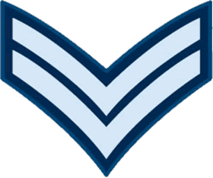

Figure 7-2-2 Corporal Rank Badge

Flight Corporal (FCpl)
Cadets may be promoted to the rank of Flight Corporal after successfully completing proficiency Level Two. The Flight Corporal rank badge has two chevrons. When worn on the jacket it is worn on the upper sleeves, centred midway between the shoulder seam and the point of the elbow.

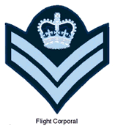

Figure 7-2-3 Flight Corporal Rank Badge

Sergeant (Sgt)
The Sergeant rank badge has three chevrons. When worn on the jacket it is worn on the upper sleeves, centred midway between the shoulder seam and the point of the elbow.

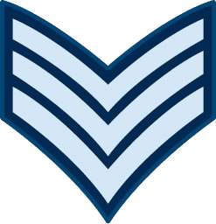

Figure 7-2-3 Sergeant Rank Badge

Flight Sergeant (FSgt)
The Flight Sergeant rank badge has three chevrons and a crown. When worn on the jacket it is worn on the upper sleeves, centred midway between the shoulder seam and the point of the elbow.

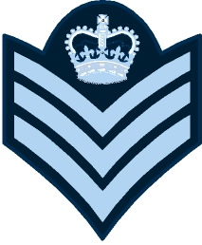

Figure 7-2-4 Flight Sergeant Rank Badge

Warrant Officer Second Class (WO 2)
The Warrant Officer Second Class badge is a crown encircled by a wreath. When worn on the jacket it is worn on the lower sleeves, centred midway between the bottom of the cuff and the point of the elbow.

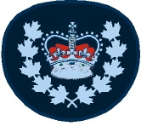

Figure 7-2-5 Warrant Officer Second Class Rank Badge

Warrant Officer First Class (WO 1)
Warrant Officer First Class is the highest rank a cadet may achieve.
The Warrant Officer First Class badge is the Canadian Coat of Arms. When worn on the jacket it is worn on the lower sleeves, centred midway between the bottom of the cuff and the point of the elbow.

Figure 7-2-6 Warrant Officer First Class Rank Badge

SUBORDINATE OFFICER – OFFICER CADET
The Officer Cadet rank is identified by one thin gold braid.

Figure 7-2-7 Officer Cadet Rank

JUNIOR OFFICERS
Once an officer is promoted to the rank Second Lieutenant they become a commissioned member of the Canadian Forces. Receiving a commission means that a person has been recognized by the monarchy (Queen or King) to serve as an officer.

Second Lieutenant (2Lt)
The rank of Second Lieutenant is identified by one thick gold braid.

Figure 7-2-8 Second Lieutenant Rank

Lieutenant (Lt)
The rank of Lieutenant is identified by one thick gold braid, with one thin gold braid on top of it.

Figure 7-2-9 Lieutenant Rank

Captain (Capt)
The rank of Captain is identified by two thick gold braids.

Figure 7-2-10 Captain Rank

SENIOR OFFICERS
Major (Maj)
The rank of Major is identified by two thick gold braids with one thin gold braid in between.

Figure 7-2-11 Major Rank

Lieutenant Colonel (LCol)
The rank of Lieutenant Colonel is identified by three thick gold braids.

Figure 7-2-12 Lieutenant Colonel Rank

Colonel (Col)
The rank of Colonel is identified by four thick gold braids.

Figure 7-2-13 Colonel Rank

GENERAL OFFICERS
General officers are unique in that there are two manners to distinguish their ranks. All four of these ranks will wear one extra thick braid on the sleeve of their dress uniform. To distinguish between the four general ranks, there are differences in their epaulettes. All of the epaulettes will have a crown over a crossed sabre and baton, with the distinguishing feature being the number of maple leafs under the swords.

Brigadier General (BGen)
The rank of Brigadier General is identified by one maple leaf under the swords.

Figure 7-2-14 Brigadier General Rank

Major General (MGen)
The rank of Major General is identified by two maple leafs under the swords.

Figure 7-2-15 Major General Rank

Lieutenant General (LGen)
The rank of Lieutenant General is identified by three maple leafs in a triangular pattern under the swords.

Figure 7-2-16 Lieutenant General Rank

General (GEN)
The rank of General is identified by four maple leafs in a diamond pattern under the swords.

Figure 7-2-17 General Rank

M107.03 Observe Rules and Procedures for the Paying of Compliments

OBJECTIVES
By the end of this lesson the cadet shall be expected to know when and where to pay compliments.

IMPORTANCE
Knowledge gained during this lesson will be applied when addressing and interacting with officers and NCOs at the corps/squadron and the Cadet Summer Training Centre.

TRAINING POINTS

ADDRESSING CADET NCOs AND SUBORDINATE OFFICERS
It is important to pay the correct compliments to the appropriate individuals. When addressing a cadet NCO or a subordinate officer, the cadet will stand at the position of attention. As cadet NCOs and subordinate officers do not hold a commission from the Queen, they are not saluted. Throughout the conversation, the cadet shall address the NCO or subordinate officer by their rank and surname and remain at the position of attention. When the cadet has completed addressing the NCO or officer, they should dismiss themselves appropriately by turning to the right.

ADDRESSING COMMISSIONED OFFICERS
When addressing commissioned officers, the same procedures are followed as when addressing NCOs and subordinate officers except a salute shall be given. The cadet shall stand at the position of attention after approaching the commissioned officer. The cadet will then give the appropriate salute as outlined in A-PD-201-000/PT-000, Canadian Forces Manual of Drill and Ceremonial. Throughout the conversation the cadet shall address the commissioned officer by their rank and surname and always remain at the position of attention unless otherwise directed by the commissioned officer. When the cadet has completed addressing the officer, they should again salute and dismiss themselves appropriately.

PAYING COMPLIMENTS INSIDE A BUILDING
Salutes are not given inside buildings except when on parade, during ceremonial occasions, or when entering and leaving offices. Cadets, however, shall turn their head and offer a polite greeting when meeting an officer in a common area. It is not customary to wear headdress inside a building.

Entering an Office
When entering an office the cadet shall: stand at the position of attention in the doorway; salute if wearing headdress and the office occupant holds a commission; and politely ask permission to enter the office.

Leaving an Office
When leaving an office the cadet shall: stand at the position of attention in the doorway; salute if wearing headdress and the office occupant holds a commission; and depart.

OTHER OCCASIONS TO PAY COMPLIMENTS
It is appropriate for cadets to salute on different occasions:
- When the Canadian or another foreign national anthem is played.
- When recognizing a commissioned officer who is not in uniform.
- When The National Flag of Canada is being lowered or raised.
- When boarding or disembarking any of Her Majesty’s Canadian ships or those of a foreign service, cadets shall pay compliments to the quarterdeck.

M107.05 WEAR THE AIR CADET UNIFORM

OBJECTIVES
By the end of this lesson the cadet shall be expected to properly care for and wear the Air Cadet uniform to the standard set forth in CATO 55-04, Royal Canadian Air Cadet Dress Instructions.

IMPORTANCE
The cadet uniform is highly recognizable and the standard of personal dress and appearance. Grooming shall be such as to reflect credit on the individual and the Canadian Cadet Organization (CCO).

TRAINING POINTS

WEDGE
The wedge shall be worn on the right side of the head with the lower point of the front crease in the centre of
the forehead and with the front edge of the cap 2.5 cm above the right eyebrow. Two air force buttons must
be attached in pre-cut holes at the front.

WEDGE INSIGNIA
The wedge insignia is to be worn on the left side of the wedge with the centre of the badge positioned midway
between the front and mid-point of the wedge.

Figure 7-5-1 Placement of Wedge Insignia

WIDE BRIMMED TAN SUMMER HAT
The wide brimmed tan summer hat may be worn during summer activities for which the wedge is unsuitable.

TOQUE
The toque may be worn outside when weather conditions dictate.

SHORT SLEEVE SHIRT
The short sleeve shirt may be worn with or without the tie. It can also be worn with or without the jacket. It shall be kept clean and pressed. The only crease is to be down the centre of each sleeve starting at the centre of each epaulette. The shirt shall be tucked into the pants and the top button shall remain open when not wearing the tie.

NECKTIE
The necktie shall be knotted neatly using a Windsor or four-in-hand knot and shall be kept tight. Plain gold
colour tie clips or pins may be used. When the jacket is removed, the tie shall not be tucked into the shirt except for safety reasons.

Figure 7-5-2 Method for Tying a Windsor Knot

LIGHT BLUE COTTON T-SHIRT
The light blue cotton T-shirt may be worn with the appropriate orders of dress. It shall be wrinkle free at all times.

TURTLENECK SWEATER
The turtleneck sweater may be worn with or without the jacket but the jacket must be worn when proceeding
to and from the squadron’s location. Sleeves shall not be rolled or taken up.

JACKET AND JACKET BELT
The cadet jacket with cloth belt shall be worn fully buttoned with the exception of the top button. Jackets may
be removed in buildings and offices when authorized. The jacket shall be kept clean and pressed. The sleeves
of the jacket shall be roll pressed with no creases. The jacket belt shall be worn so as the excess of the belt,
once attached, is on the left side of the buckle. The buckle shall be adjusted so that the excess of the belt on
the left side is not more than 8 cm.

ALL-SEASON JACKET
The all-season jacket may be worn year round when weather conditions dictate. The liner and the exterior
jacket may be worn separately or as a set. Rank slip-ons shall be worn on both.

RANK SLIP-ONS
Rank slip-ons shall be worn on both shoulders with the short-sleeve shirt, the all-season jacket, with the CF
flying suit at the flying site for authorized cadets and with CF combat clothing during squadron survival exerciseswhen authorized by the squadron CO.

GREY SPORTS T-SHIRT
The grey sports T-shirt shall be worn as directed by the squadron or CSTC CO.

BLACK GLOVES AND MITTS
Plain black civilian pattern gloves and mitts may be worn with the overcoat, parka, or all-season jacket when
weather conditions dictate.

NAMETAG
The nametag shall be made of a blue and white laminated plastic plate 6.3 cm in length and 1.2 cm in height. It
shall be inscribed with white lettering 0.6 cm high and shall indicate only the surname of the cadet. The nametag is worn over the right breast pocket and should be detachable.

Figure 7-5-4 Right Breast Pocket with Nametag
TROUSERS
The trousers shall be steam pressed without starch so as to have creases down the centre of each leg in the
front and the back. Creases shall extend from the top of the leg to the bottom and shall not be sewn or glued.

BLACK BELT
The black belt shall be worn with the trousers such that the buckle is centred and the ends are “brass on brass”.
Brass on brass is when the end of the belt meets the brass buckle, and when the belt is done up, there is no
black showing between the two pieces of brass. The belt may need to be adjusted in order for this to occur.

GREY SPORTS SHORTS
The grey sports shorts shall be worn as directed by the squadron or CSTC CO.

BOOTS
Black ankle boots are to be laced horizontally from side-to-side.

Figure 7-5-5 Method of Lacing Boots
When the boots are tied, the ends of the laces are to be tucked inside the boot. Boots shall not be modified
with any type of metal cleats, hobnails or other metal attachments to the heel or sole. No varnish other than
shoe polish will be used to shine the boots.

CARE OF THE BOOTS
The black ankle boots should be cleaned and polished on a regular basis. General guidelines for polishing
the boots include:
1. The welts of the boot are to be cleaned with an old toothbrush and black boot polish.
2. Use a polish cloth wrapped around the index finger.
3. Apply a moderate amount of polish to the cloth.
4. Apply the polish in a circular motion to the area being polished.
5. Start with large circles to cover the area with polish.
6. Use smaller circles as the polish gets worked into the boot.
7. Continue to work in a circular motion until circles formed by the polish are no longer visible.
8. The whole boot is to be polished, not just the toe.

RUNNING SHOES
Running shoes shall be worn as directed by the squadron or CSTC CO.

GREY WOOL SOCKS
Grey wool socks shall be worn with boots and running shoes. If a cadet suffers from a recognized allergy to
wool the cadet may wear grey or black cotton or nylon socks

SQUADRON SHOULDER BADGES
Squadron shoulder badges are to be worn on both sleeves of the jacket only. The top of the badge is to be
2 cm below the upper shoulder seam.
Figure 7-5-6 Squadron Shoulder Flash
LAC RANK BADGES
LAC rank badges are to be worn centered on both sleeves of the jacket, midway between the elbow and the
upper shoulder seam.
Figure 7-5-7 LAC Rank Badge

GENERAL APPEARANCE
Cadets in uniform shall be well groomed with footwear cleaned and shone. Uniforms shall be clean and properlypressed at all times. In particular, buttons, fasteners and zippers shall be kept closed. Pockets shall not bulge. Items such as glasses, sunglasses, glasses cases, pens, pencils, key-rings or paper shall not visibly extend or protrude from pockets or be suspended from waist belts or pockets. Headsets from a radio receiver, tape/CD player or other personal entertainment devices shall not be worn.
Hairstyles
Hair shall be neatly groomed and conservatively styled. The length, bulk and style of hair shall not preclude
the proper wear of the wedge. Style and colour shall not be bizarre, exaggerated or of unusual appearance.
Unusual colours such as green, bright red, orange, purple, etc. are not permitted.
Male Hairstyles
Male cadets’ hair shall be taper trimmed at the back, sides, and above the ears to blend with the hairstyle. It
shall be no more than 15 cm in length. When the hair is groomed and wedge is removed, no hair shall touch
the ears or fall below the top of the eyebrows.

Figure 7-5-8 Taper Trimmed Haircut – Conventional

Figure 7-5-9 Taper Trimmed Haircut – Straight Back Appearance

Sideburns
Sideburns shall not extend below a line horizontally bisecting the ear. They shall be squared off horizontally at
the bottom edge and taper trimmed to conform to the overall hairstyle.

Moustaches
When moustaches are worn, the unshaven portion of the face shall not extend outwards beyond the corners
of the mouth. Moustaches shall be kept neatly trimmed, not be greater than 2 cm (3/4 in.) in bulk, not extend
below the corners of the mouth, and not protrude beyond the width of the mouth.

Figure 7-5-10 Moustache

Female Hairstyles
Female cadets’ hair shall not extend below the lower edge of the shirt collar.

Figure 7-5-11 Female Short Hairstyles
Hair may be worn in a bun at the back of the head.

Figure 7-5-12 Hair Styled in Bun

Braids shall be styled conservatively and tied tightly. They shall be secured at the end by a knot or a small
unadorned fastener. A single braid shall be worn in the centre of the back. Double braids shall be worn behind
the shoulders. When gathered behind the head and braided hair shall be a maximum length that does not
extend below the top of the armpit.

Figure 7-5-13 Single Braid Figure 7-5-14 Double Braids

Make-up
Female cadets are authorized to wear a minimal amount of make-up. When wearing the uniform, make-up
shall be applied conservatively. This precludes the use of false eyelashes, heavy eyeliner, brightly coloured
eye shadow or lipstick, coloured nail polish, and excessive facial make-up.
Jewellery
The only jewellery that may be worn in uniform shall be a wristwatch, a medical alert bracelet and a maximum
of two rings, which are not of a costume jewellery nature. Female cadets in uniform may wear a single pair of plain gold studs, silver stud or white pearl earrings in pierced ears. The single stud earring (worn in the centre of each earlobe) shall be spherical in shape and not exceed 0.6 cm in diameter. Male cadets are not authorized to wear an earring or earrings.

Figure 7-5-15 Stud Earring Centred in Earlobe

Tattoos and Piercings
Cadets shall not acquire visible tattoos that could be deemed to be offensive or otherwise reflect discredit on
the Canadian Cadet Movement. Cadets in uniform shall not wear visible body piercing adornments (tongue
included). Covering the unauthorized piercing with an adhesive bandage is not acceptable.

Accessories
Civilian pattern backpacks shall be of conservative appearance. They may either be carried in the left hand or
worn suspended from both shoulders and square on the back.
Female cadets are permitted to carry a purse. The purse is to be held in the left hand or suspended over the
left forearm. When the purse is carried as a shoulder bag, the strap shall be suspended from the left shoulder
with the top of the purse not higher than waist level. It shall not be carried as a handbag.

Eyeglasses/Sunglasses
Eyeglasses and sunglasses shall be conservative in design and colour. Sunglasses with photo chromic
or mirrored lenses are not authorized for wear. Cadets, who normally wear eyeglasses, may wear either
conventionally framed prescription sunglasses or conservatively styled clip-on sunglasses when conditions and
circumstances dictate. Other cadets may wear conservatively styled sunglasses, which do not detract from the
overall appearance of the uniform when conditions and circumstances dictate. Sunglasses shall not be worn
when parading unless authorized by the CSTC or Squadron CO in special circumstances.

Carrying of Articles
If any article is being carried, such as a briefcase, it is to be carried in the left hand. If an article is being carried
while marching, the left arm is not swung.

Civilian Clothing
Other than those specific items listed in the CATO, civilian clothing shall not be worn with the cadet uniform
unless authorized by the CSTC or squadron CO in special circumstances. This includes, but is not limited to,
civilian jackets and hats.

General Deportment
Chewing gum, slouching, sauntering, placing hands in pockets, smoking, eating on the street, walking handin-
hand and similar deportment that detracts from a proud and orderly appearance in the eyes of the public is
unacceptable for cadets. Physical displays of affection between uniformed cadets shall be avoided.

C107.01 – MAINTAIN THE AIR CADET UNIFORM

OBJECTIVES
By the end of this lesson the cadet shall be expected to be able to maintain the air cadet uniform

IMPORTANCE
The cadet uniform is highly recognizable and the standard of personal dress, appearance and grooming shall
be such as to reflect credit on the individual and on the Canadian Cadet Organization (CCO).

TRAINING POINTS

THE PRESSING CLOTH
There are several points to keep in mind when ironing the uniform. A pressing cloth should always be used to
prevent the parts of the uniform from becoming shiny.
Some examples of what can be used as a pressing cloth include:
- thin towel;
- pillow case;
- soft cotton cloth; and
- paper bag.

TROUSERS
The instructor shall demonstrate the correct method of care for the trousers to include: ensuring trousers are well pressed and free of dirt and lint at all times; and pressing the trousers, in accordance with the standard outlined in EO M107.05 (Section 5), which is achieved by: lining the pant leg up by the seams to ensure the creases are properly positioned at the centre of
- the front and back of the leg;
- laying the pant leg flat on the ironing board;
- spraying the pants with water from a water bottle;
- placing a pressing cloth over the pant leg;
- ironing the pants until a sharp crease extends down the centre of each leg in the front and back, from
- the top of the leg to the bottom; and
- ironing on the same crease each time in order to avoid double creases.

SHORT SLEEVE SHIRT
The instructor shall demonstrate the correct method of care for the short sleeve shirt to include: ensuring the short sleeve shirt is clean; and pressing the short sleeve shirt, in accordance with the standard outlined in EO M107.05 (Section 5), which is achieved by:
- pressing the entire short sleeve shirt to ensure it is free of wrinkles by laying it flat on the ironing board;
- pressing the sleeves flat with the top of the sleeve laid flat to ensure a sharp crease is formed down the centre of each sleeve starting at the centre of each epaulette. There should only be one crease in each sleeve; and
- the collar may be starched to prevent it from becoming limp.

JACKET
The instructor shall demonstrate the correct method of care for the jacket to include:
- ensuring the jacket is clean; and
- pressing the jacket, in accordance with the standard outlined in EO M107.05 (Section 5), which is achieved by:
- pressing the front and back of the jacket to ensure it is free of wrinkles;
- ensuring the pockets on the front of the jacket are pressed flat; and
- ensuring the sleeves of the jacket are roll pressed so they are free of creases by ironing the sleeves in sections but not ironing the edges.

BOOTS
The instructor shall demonstrate caring for the boots to include:
- polishing, in accordance with the general guidelines outlined in EO M107.05 (Section 5), which is achieved
by:
- cleaning the welts of the boot with an old toothbrush and black boot polish;
- using a polish cloth wrapped around the index finger;
- applying a moderate amount of polish to the cloth;
- applying the polish in a circular motion to the area being polished;
- starting with large circles to cover the area with polish;
- using smaller circles as the polish gets worked into the boot;
- continuing to work in a circular motion until circles formed by the polish are no longer visible; and
- the whole boot is to be polished, not just the toe;
- lacing the boots, which is achieved by:
- lacing them straight across;
- tucking the laces inside the boots; and
- boots should not be tied to tightly.

HAIRSTYLES
The instructor shall demonstrate hairstyles in accordance with EO M107.05 (Section 5), which is achieved by
ensuring:
- hair is neatly groomed and conservatively styled;
- the wearing of the wedge is not precluded by the length, bulk and style of the hair;
- the style and colour is not bizarre, exaggerated or of unusual appearance;
- the hair is secured or styled back to reveal the face. Any accessories used to secure or control hairstyles
- shall be unobtrusive;
- that male cadets’ hair is taper trimmed at the back, sides and above the ears to blend with the hairstyle;
- the hair is not touching the ears or falling below the top of the eyebrows when the wedge is removed;
- that sideburns are not extending below a line horizontally bisecting the ear, are not squared off horizontally
- at the bottom edge, and are taper trimmed to conform to the overall hairstyle;
- that female cadets’ hair is not extending below the lower edge of the shirt collar;
- that braids are styled conservatively, tied tightly, and secured at the end by a knot or a small unadorned
- fastener;
- a single braid is worn in the centre of the back; and
- that double braids are worn behind the shoulders.

C107.02 – IDENTIFY THE AIR FORCE NCM RANK STRUCTRE
OBJECTIVES
By the end of this lesson the cadet shall identify the NCM rank structure of the air element of the Canadian
Forces.

IMPORTANCE
Cadets will often come in contact with personnel from the Canadian Forces. It is important that they be able
to use proper marks of respect.

TRAINING POINTS

AIR FORCE NCM RANK STRUTURE
The NCM rank structure for the air element of the Canadian Forces (CF) is as follows:
Private Recruit (Pte R). The Private Recruit rank has no rank badge.
Figure 7-8-1 Private Recruit Rank

Private (Pte). The Private rank consists of one chevron.
Figure 7-8-2 Private Rank
Corporal (Cpl). The Corporal rank consists of two chevrons.

Figure 7-8-3 Corporal Rank

Master Corporal (MCpl). The Master Corporal rank consists of two chevrons with a maple leaf on top.
Figure 7-8-4 Master Corporal Rank

Sergeant (Sgt). The Sergeant rank consists of three chevrons with a maple leaf on top.

Figure 7-8-5 Sergeant Rank

Warrant Officer (WO). The Warrant Officer rank consists of a Tudor crown.
Figure 7-8-6 Warrant Officer Rank

Master Warrant Officer (MWO). The Master Warrant Officer rank consists of a Tudor crown surrounded
by a wreath.
Figure 7-8-7 Master Warrant Officer Rank
Chief Warrant Officer (CWO). The Chief Warrant Officer rank consists of the Canadian Coat of Arms.

Figure 7-8-8 Chief Warrant Officer Rank

PO 129 – COMMUNICATE USING THE PHONETIC ALPHABET AND NUMBERS

M129.01 RECITE THE PHONETIC ALPHABET

OBJECTIVES
By the end of this lesson the cadet shall be expected to recite the alphabet and numbers phonetically.

IMPORTANCE
It is important to know how to properly say the alphabet and numbers while communicating over a radio. This
knowledge will help avoid confusion through the pronunciation of letters and numbers and the misinterpretation of messages. Cadets can use this information during flying and aircrew survival training.

TRAINING POINTS

PHONETIC ALPHABET
The phonetic alphabet is used because letters that sound similar might be confused when said over a radio.
An example of similar sounding letters is “M” and “N”. Therefore, each letter of the alphabet is associated with a word that is easily understood over the radio.

The phonetic alphabet is as follows:
A – Alpha
B – Bravo
C – Charlie
D – Delta
E – Echo
F – Foxtrot
G – Golf
H – Hotel
I – India
J – Juliet
K – Kilo
L – Lima
M – Mike
N – November
O – Oscar
P – Papa
Q – Quebec
R – Romeo
S – Sierra
T – Tango
U – Uniform
V – Victor
W – Whiskey
X – X-ray
Y – Yankee
Z – Zulu

Use of the phonetic alphabet can be heard on a familiarization flight when the pilot communicates the aircraft’s
call letters to the tower

PHONETIC NUMBERS
Phonetic numbers are used to avoid misunderstandings when using radio communication. Numbers are
enunciated in the following manner:
0 – Zee-ro
1 – Wun
2 – Too
3 – Tree
4 – Fow-er
5 – Fife
6 – Six
7 – Seven
8 – Ait
9 – Nin-er

Numbers are always spoken as single digits, except for whole thousands. For example, 5280 would be spoken
“fife too ait zee-ro” and 5000 would be spoken “fife tou-sand.”
Symbols are spoken out as words over the radio; e.g. the word decimal, pronounced “day-see-mal”, is used
where there is a number with a decimal point.
Air traffic controllers use phonetic numbers to communicate to pilots what runway to use when taking off and
landing.

PO 130 – PARTICIPATE IN AVIATION ACTIVITIES

M130.01 – IDENTIFY AIRCRAFT AS MILITARY, CIVILLIAN AND CADET

OBJECTIVES
By the end of this lesson the cadet shall identify examples of military, civilian and cadet aircraft.

IMPORTANCE
Basic aircraft identification creates a base of understanding for further aviation topics. It adds value to additional aviation activities such as aerodrome tours, air shows and familiarization flying. It also fosters an interest in the military and civilian aviation communities by introducing cadets to aircraft commonly found in those communities.

CANADIAN MILITARY AIRCRAFT
Military aircraft are used for a wide variety of tasks. These tasks include training, transport, maritime patrol,
defence and search and rescue. Most military aircraft are painted flat grey or camouflage for low visibility. Those high visibility planes used for Search and Rescue (SAR) work are painted bright yellow and red.

CT-114 TUTOR
The CT-114 Tutor may be the most well known aircraft flown by the Canadian Forces (CF). It is the plane flown
in the Snowbirds air demonstration squadron. The Tutor was used as a training aircraft from 1971 until 2000.
It was designed and built in Canada. The Tutor has a single jet engine, low wings and a T-tail.

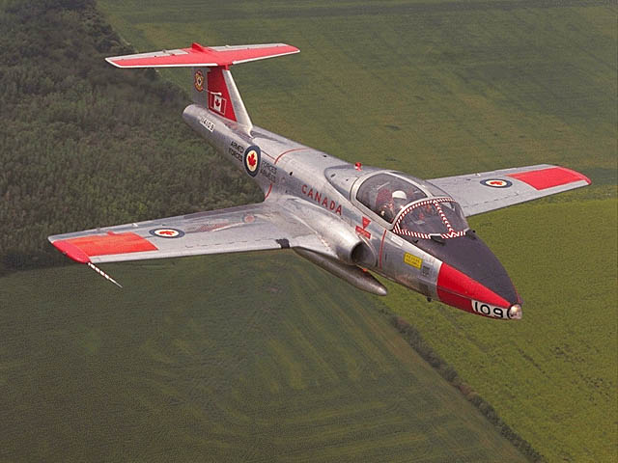

Figure 12-1-1 CT-114 Tutor

CC-115 BUFFALO
The CC-115 Buffalo is mainly used for SAR operations. It has short take-off and landing (STOL) capability,
which is ideal for rough landing strips. It is able to fly in almost any weather. The Buffalo is painted a highly
visible yellow. It has two turboprop engines, high wings and a T-tail.

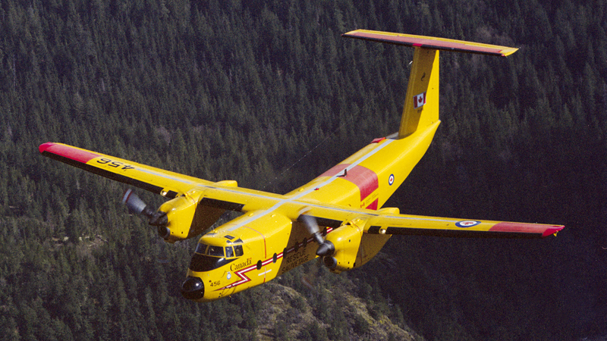

Figure 12-1-2 CC-115 Buffalo

CC-130 HERCULES
The CC-130 Hercules is one of the most multi-purpose transport planes. It is used to airlift troops, equipment
and cargo. It is also used in SAR operations and in air-to-air refuelling of fighters. With its rear cargo ramp,
rugged landing gear, good short-field performance and high ground clearance of engines/propellers, the C-
130 is designed to operate from unimproved airstrips in active military areas. The Hercules has four turboprop
engines, high wings and a distinctively large tail.
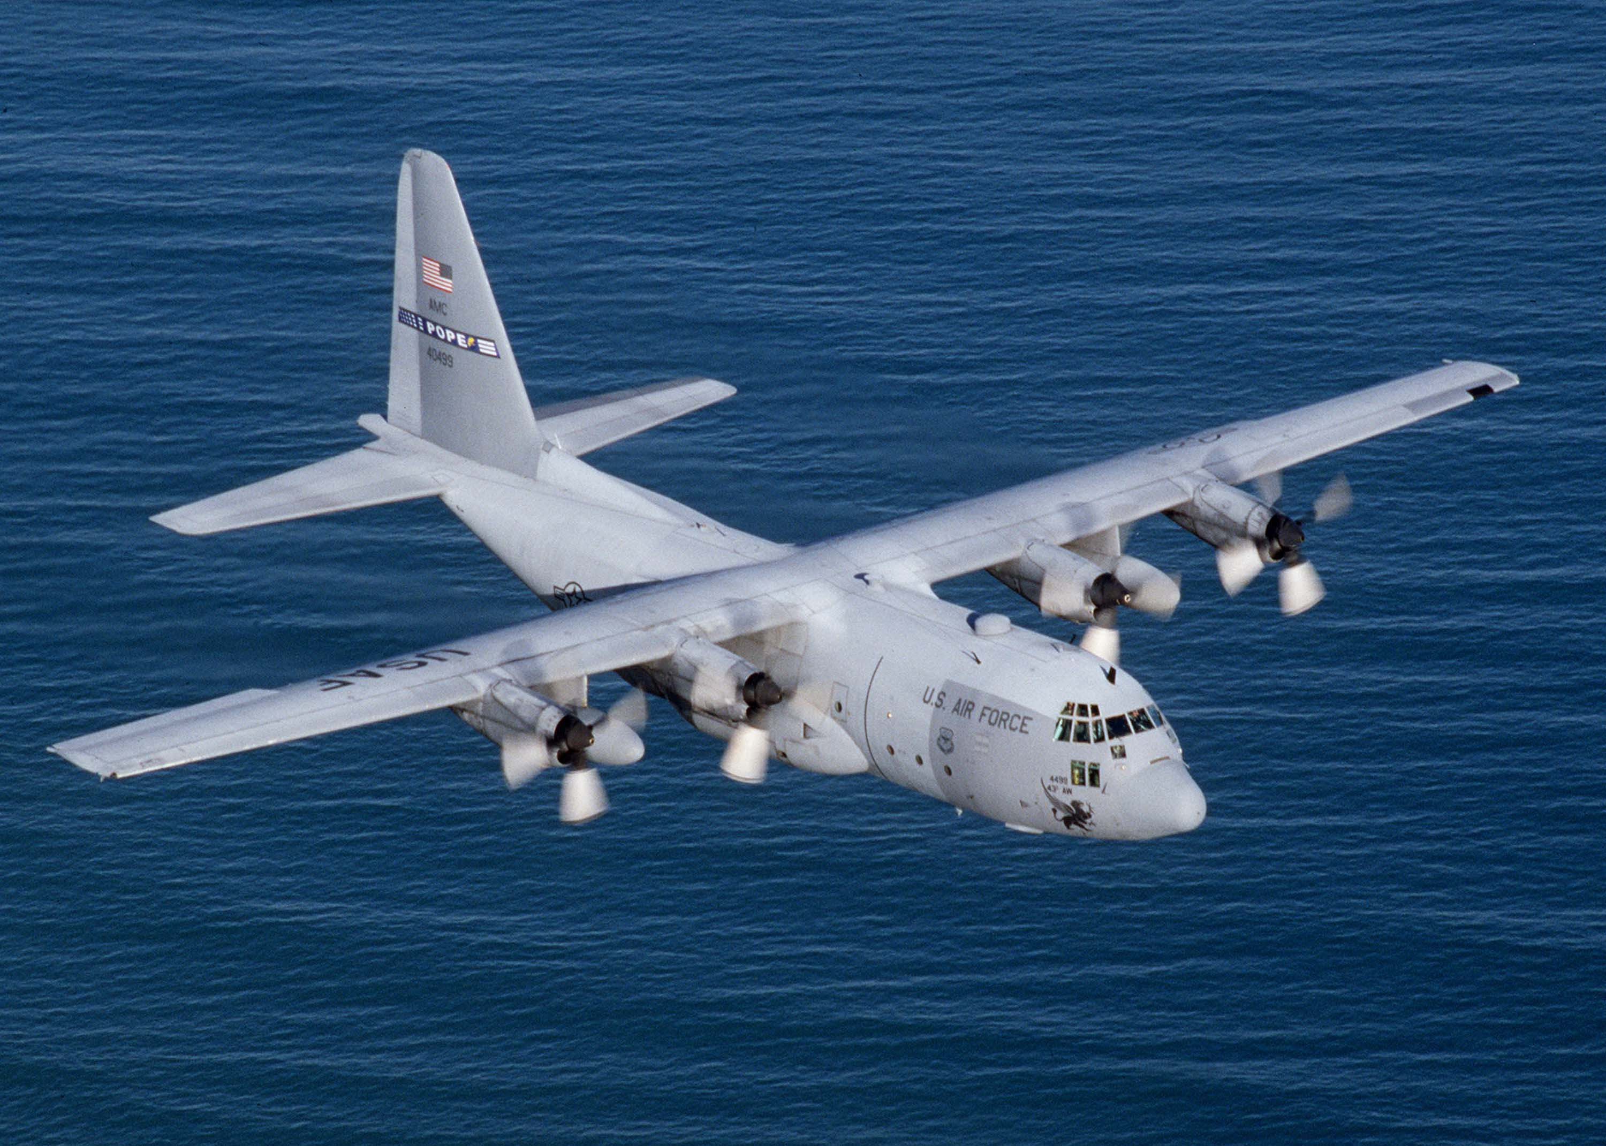

Figure 12-1-3 CC-130 Hercules

CC-150 A310 POLARIS
The CC-150 Polaris is the military version of a popular civilian commercial airliner, the Airbus A310-300.
The main role of the Polaris is long-range transport of personnel and equipment. It can transport up to 194
passengers or 32 000 kg of cargo. The CC-150 is a wide-body, two engine turbojet with low wings.
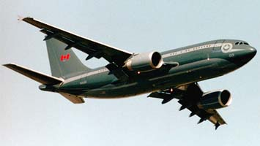

Figure 12-1-4 CC-150 Polaris

CP-140 AURORA
The CP-140 Aurora is a maritime patrol aircraft. It carries special sensing equipment aboard so it can detect
and monitor boats and submarines. The prominent tail boom is the most obvious feature of this aircraft. It has
four turboprop engines and low wings.

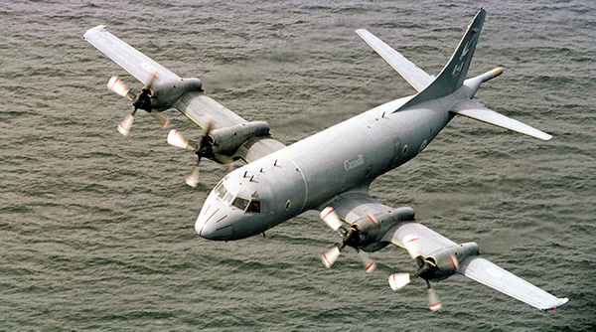

Figure 12-1-5 CP-140 Aurora
CF-18 HORNET
The CF-18 Hornet is a high-performance twin-engine jet fighter that can perform air-to-air combat or groundattack roles. The most visible difference of the CF version of this aircraft is a paint scheme incorporating a “spoof” canopy on the underside of the front fuselage. This “spoof” canopy is used to confuse an opponent in the heat of a dogfight as to “which side is up”. The distinctive angled twin vertical fins on the tail most easily identify the CF-18.

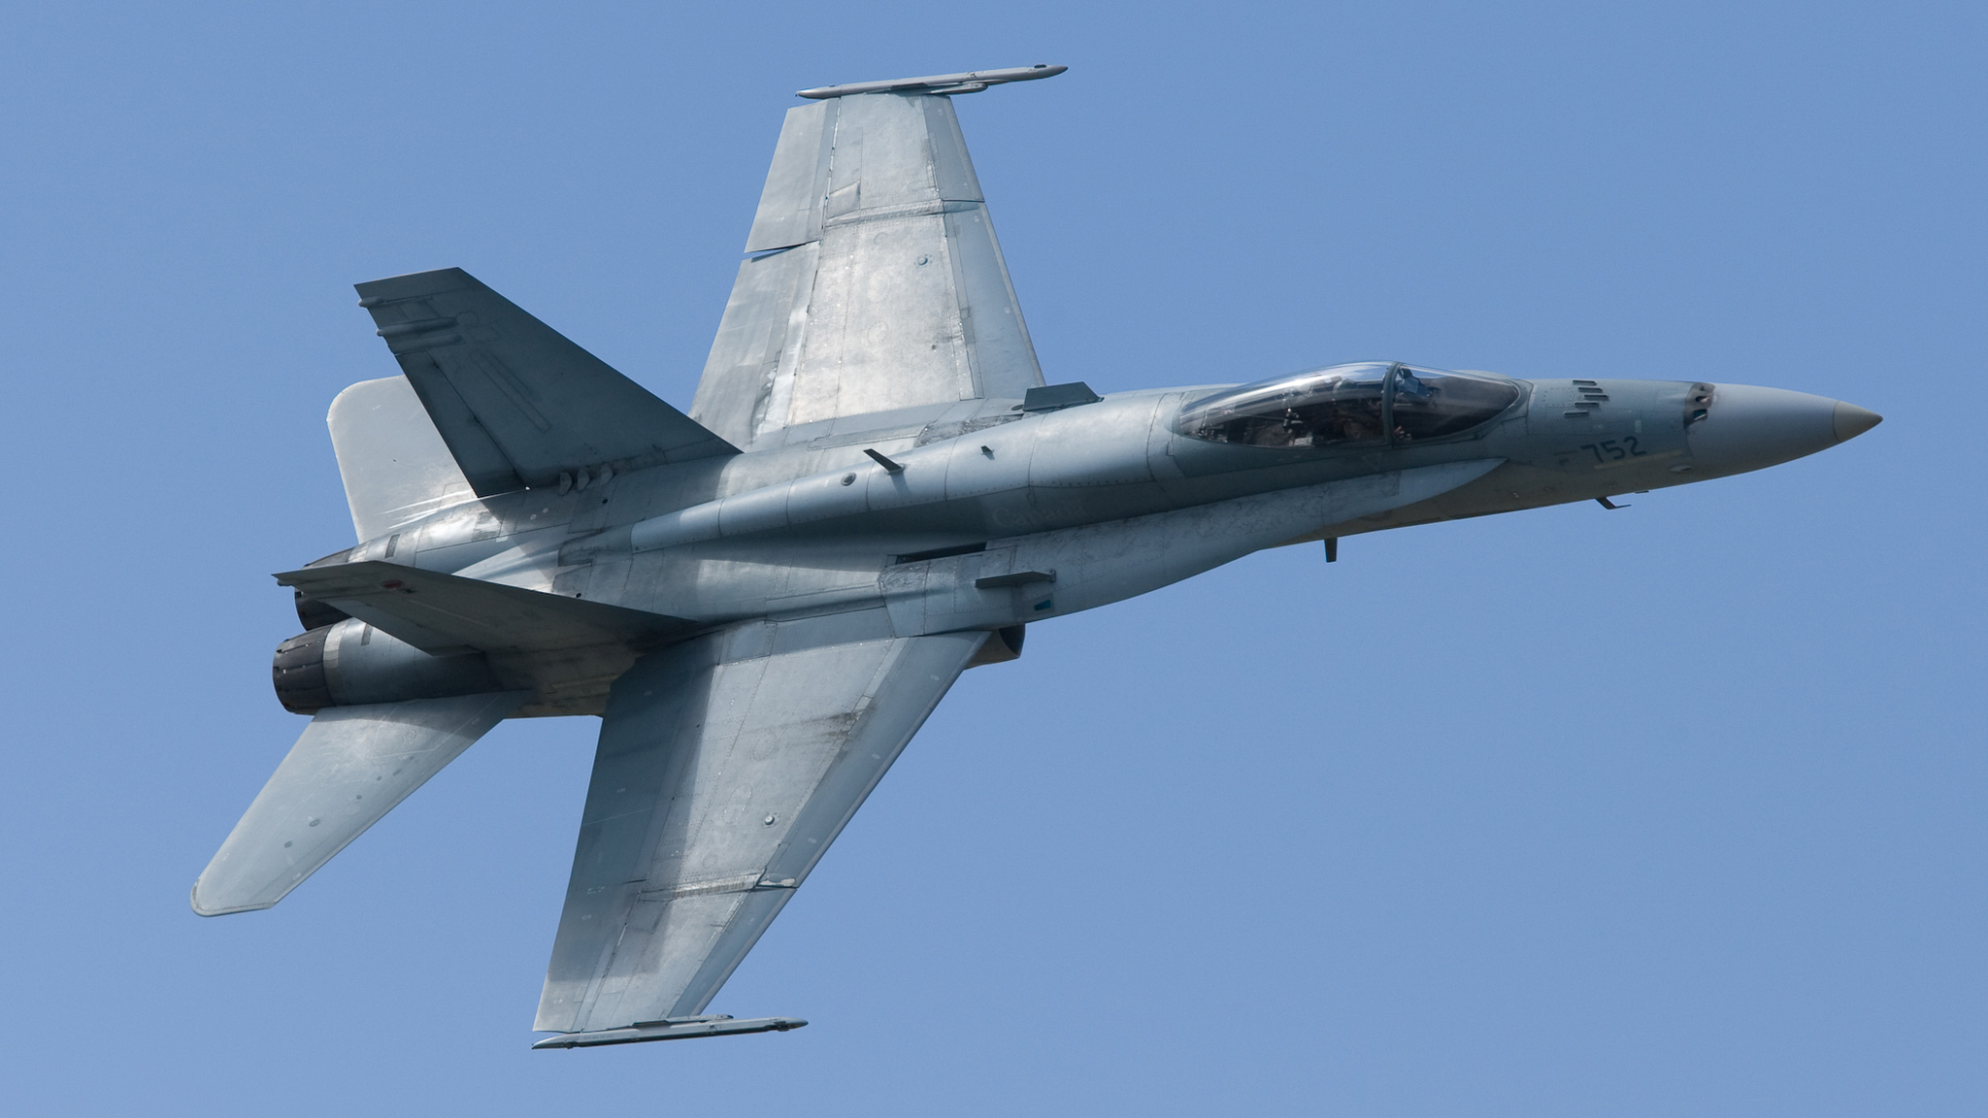

Figure 12-1-6 CF-18 Hornet

CH-146 GRIFFON
The CH-146 Griffon is Canada’s Utility Transport Tactical Helicopter (UTTH). It performs a wide variety of roles that include airlift of equipment and personnel, command and liaison flights, surveillance and reconnaissance, casualty evacuation, logistic transport, search and rescue, counter-drug operations and domestic relief operations. The Griffon has a four-blade main rotor and landing skids. It has a camouflage paint scheme.

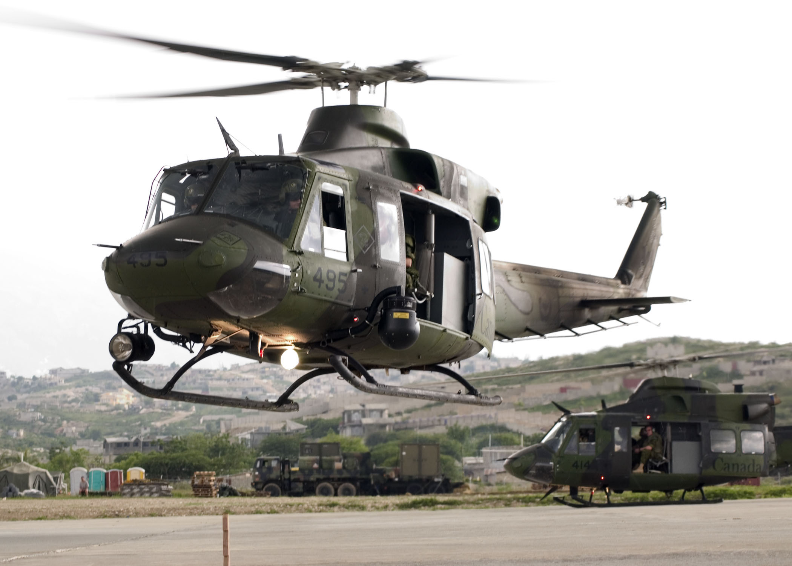

Figure 12-1-7 CH-146 Griffon

CH-149 CORMORANT
The CH-149 Cormorant is a SAR helicopter. It has three powerful engines that drive a five-bladed rotor. Its
ice protection system allows it to operate in continuous icy conditions. It is also able to withstand high winds.
These features make it ideal for Canada’s demanding geography and climate. The Cormorant has rear-ramp
access and a large amount of cabin space. It can carry 12 stretchers or a load of 5000 kg. Unlike the Griffon,
the Cormorant has retractable landing gear and is painted bright yellow.

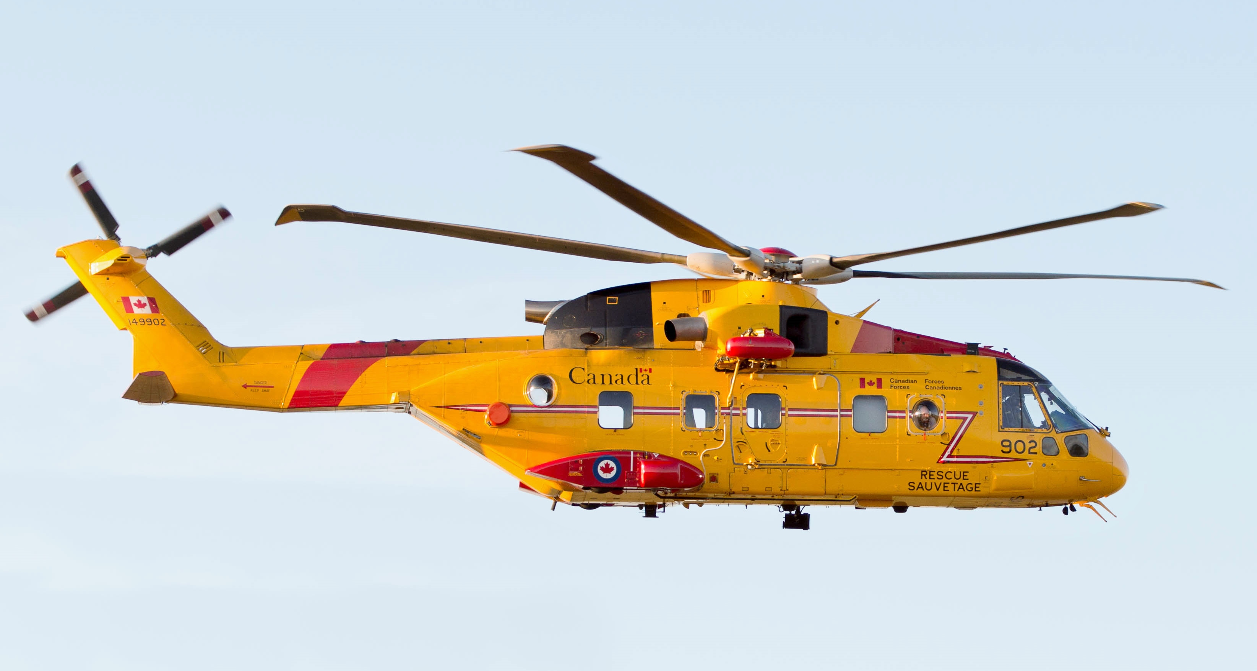

Figure 12-1-8 CH-149 Cormorant

CIVILIAN AIRCRAFT
Civilian aircraft are used in a wide variety of roles including recreational, training, and transportation of people
and cargo. Civilian aircraft have a wide range of paint schemes and use more colors than military aircraft. These aircraft are seen at civilian aerodromes.

CESSNA 172
The Cessna 172 is commonly used for primary flight training and familiarization flying. It is a four seat aircraft
that has high wings, tricycle landing gear and a single propeller.

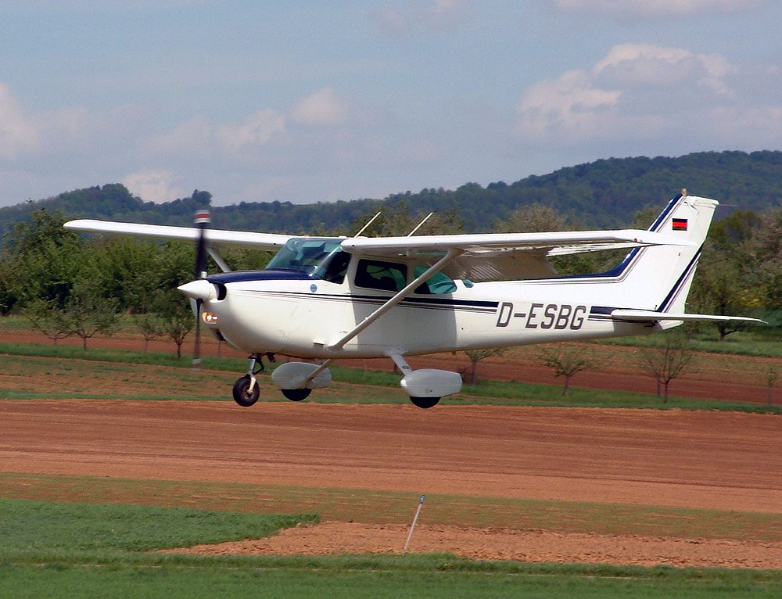

Figure 12-1-9 Cessna 172

PIPER PA-28 CHEROKEE
Another popular recreational and training aircraft is the Piper PA-28 Cherokee. This aircraft has low wings,
tricycle landing gear and a single propeller.
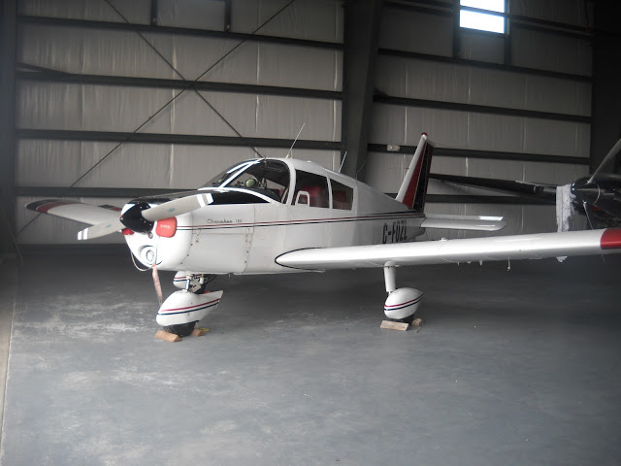

Figure 12-1-10 Piper PA-28

BOEING 737
The Boeing 737 is one of the world’s most popular commercial jet transport aircraft. It is a short to medium
range airplane. It can carry 85 to 189 passengers, depending on the model. The Boeing 737 is flown by airlines
including WestJet. The Boeing 737 has a low-wing configuration and tricycle landing gear, like most commercial transport planes. It has two turbofan jet engines mounted under the wings.
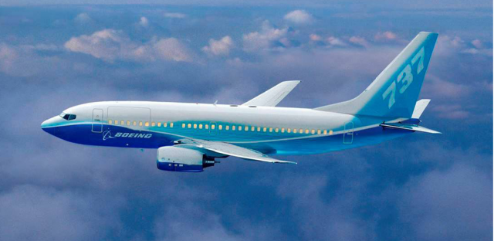

Figure 12-1-11 Boeing 737

AIRBUS A320
The Airbus A320 is a very popular commercial jet transport aircraft. It can carry 100 to 220 passengers,
depending on the model. The Airbus 320 also has a low-wing configuration, nose gear, and two turbofan
jet engines mounted under the wings. The biggest difference between the Airbus and the Boeing 737 is the
technology in the cockpit. Airbus uses computer technology to a greater extent than Boeing. Air Canada flies
the Airbus A320, and several other Airbus models.

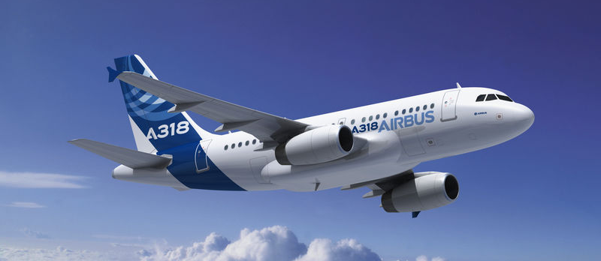

Figure 12-1-12 Airbus A320

CADET AIRCRAFT
Cadet aircraft are used for training and familiarization flying. They are usually painted bright yellow and blue.
(The term “cadet aircraft” is intended to mean aircraft currently owned by the Cadet Program and does not
include other aircraft cadets may use on Power Flying Scholarships (Cessnas, Katanas, etc.).

SGS 233A GLIDER
The Schweitzer SGS 233A is the glider used by the Air Cadet Program for training and familiarization flying. It is a sturdy, two-place glider, with high wings. It can be launched by auto-tow, winch or tow-plane.
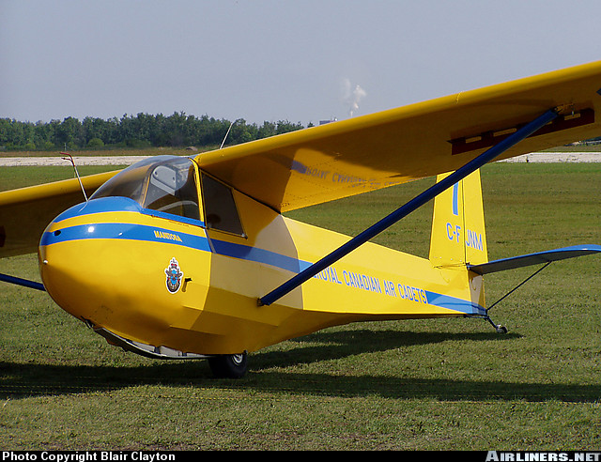

Figure 12-1-13 SGS 233A Glider

BELLANCA SCOUT
The Bellanca Scout is one of the types of tow-planes used in the Air Cadet Gliding Program. It is a two-place
tandem (front and back seating, instead of side by side), high wing, tail-dragger aircraft.

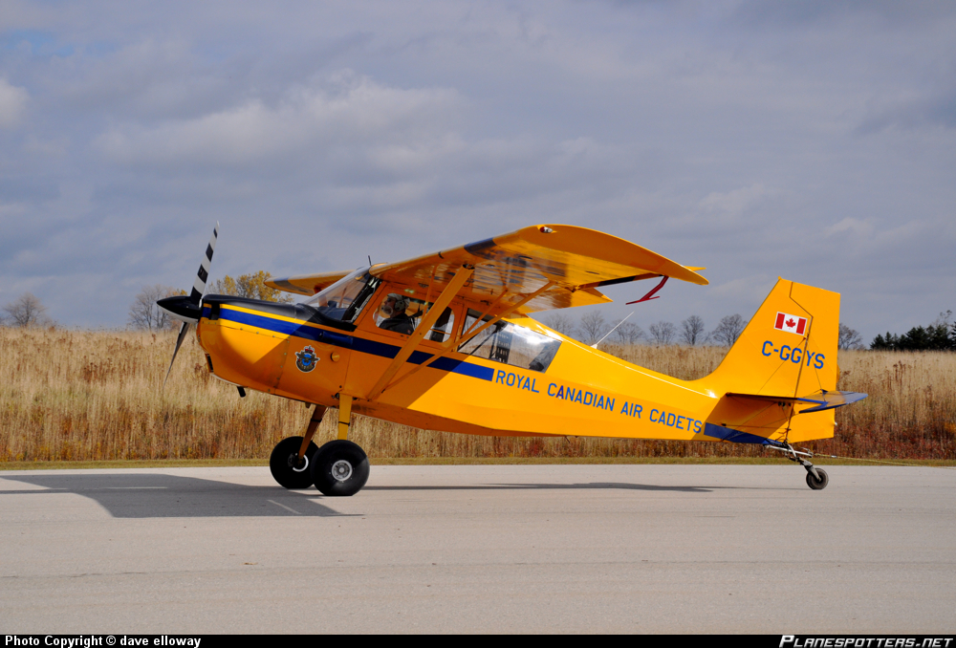

Figure 12-1-14 Bellanca Scout

L19 BIRD DOG
The L19 Bird Dog is another tow-plane used in the Air Cadet Gliding Program. Like the Scout, the Bird Dog
is a two-place tandem, high wing, tail-dragger aircraft. However, the L19 has a rear window, and more of a
bend to the fuselage than the Scout.
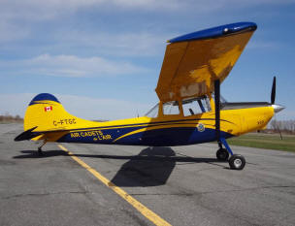

Figure 12-1-15 L19 Bird Dog

M130.02 - DESCRIBE THE MAIN COMPONENTS OF AN AIRPLANE

OBJECTIVES
By the end of this lesson the cadet shall be expected to describe the five main components of an airplane,
to include:
- fuselage;
- wings;
- empennage;
- landing gear; and
- propulsion system.

IMPORTANCE
A basic understanding of the components of an airplane will provide a foundation for further aviation topics.
It will create a familiarity with airplanes that will contribute to the cadets’ appreciation of the familiarization of
flying and aviation tour experiences.

TEACHING POINTS

DEFINITIONS
An aircraft is a device that is used or intended to be used for flight in the air. Some examples of aircraft are
hot air balloons, blimps, gliders, planes, helicopters, and hang gliders. (Electronic code of federal regulations
Title 14: Aeronautics and Space, Section 1.1)
An airplane is a power-driven heavier-than-air aircraft deriving its lift in flight from aerodynamic reactions (lift) on surfaces that remain fixed under given conditions of flight (wings). (From the Ground Up: Millennium Edition,p. 9)

FUSELAGE
The fuselage is the body of the aircraft, designed to accommodate the crew, passengers and cargo. The cockpit
or crew flight deck is the part of the fuselage where the pilot and flight crew operate the aircraft. The fuselage
is the structural body to which the wings, the tail section, landing gear and (in most small aircraft) the engine
are attached.

Figure 12-2-1 Airplane Components
WINGS
The fuselage is fitted with a wing on both sides. The primary purpose of the wings is to support the aircraft
in flight by producing lift.
The wing root is where the wing meets the fuselage. The wing tip is the part farthest from the fuselage.
The leading edge is the front edge of the wing running from wing root to wing tip. The trailing edge is the back
edge of the wing running from wing root to wing tip.
Ailerons are moveable surfaces that are hinged to the trailing edge of each wing, close to the wingtip. The
ailerons control roll. Roll is the banking of the aircraft to the left and the right. The ailerons move in opposite
directions to each other.
Flaps are moveable surfaces that are hinged to the trailing edge of each wing, closer to the wing root than the
ailerons. They can be used during landing and take-off to provide more controlled flight at slower airspeeds.
Flaps are operated with a lever or hand wheel in the cockpit.

EMPENNAGE
The empennage refers to the whole tail section of a plane. It includes the horizontal stabilizer, elevator, vertical
stabilizer, and rudder.
The horizontal stabilizer is at the back of the aircraft, and helps keep the aircraft stable as it flies through the
air. The horizontal stabilizer does not move.
The elevator is hinged to the horizontal stabilizer and is operated by moving the control column forward and
backward. The elevator controls pitch. Pitch is the up and down movement of the aircraft’s nose.
The vertical stabilizer, also called the fin, is an upright surface on the empennage. It helps keep the aircraft
stable as it flies through the air. The vertical stabilizer does not move.
The rudder is hinged to the fin and is operated by the rudder pedals in the cockpit. The rudder controls yaw.
Yaw is the side-to-side movement of the aircraft.

Figure 12-2-2 Empennage

LANDING GEAR
Landing gear on an airplane is like the tires on a car. The landing gear supports the aircraft when it is on the
ground and absorbs the shock of landing. All aircraft have their landing gear under the main part of the fuselage
or wings. Landing gear can be fixed or retractable. Fixed gear is attached to the airplane in a permanent position.
Retractable gear can fold-up into the wings or the fuselage.
There are two main landing gear configurations. Both configurations have the main wheels or main gear toward
the middle of the aircraft. In a nose wheel configuration (also called tricycle) there is another wheel or gear
under the nose. In a tail wheel configuration (also called conventional or tail dragger) there is another wheel
or gear under the tail.

Figure 12-2-3 Nose Gear vs Tail Gear

PROPULSION SYSTEM
Power is produced by an internal combustion engine (the same as a car) with a two or three blade propeller or
a gas turbine (jet) engine. A jet can be used to power a propeller – this is called a turboprop engine.
The cowling (also called the nacelle) is like the hood of a car. It encloses the engine and streamlines the airplane to reduce drag. The cowling provides cooling of the engine by ducting cool air around the engine.

PO 160 – PARTICIPATE IN AERODROME OPERATIONS ACTIVITIES

M160.01 – IDENTIFY MAJOR AERODROM COMPONENTS

OBJECTIVES
By the end of this lesson the cadet shall be expected to identify the major components of an aerodrome, to
include:
- runway;
- taxiway;
- apron;
- hangars;
- ramp areas;
- control towers;
- terminal buildings;
- wind socks;
- flying schools; and
- fire department.

IMPORTANCE
Knowing the various components of an aerodrome will assist cadets in identifying the components during
aerodrome tours and familiarization flights. This information will also be useful in future lessons, including the
activity associated with EO M160.03 (Section 3).

TRAINING POINTS

AERODROME
Around the world there is an intricate system of aeronautical facilities designed to facilitate the efficient
movement of air traffic. These many aerodromes vary widely in the facilities and the services they offer.
However, there are certain standard features that apply to every aerodrome.
An aerodrome is any area of land or water designed for the arrival, departure and movement of aircraft (From
the Ground Up: Millennium Edition, 2000, p. 91).

AIRPORT
An airport is a licensed aerodrome, which possesses a certificate stating it has met all airport safety standards
(From the Ground Up: Millennium Edition, 2000, p. 91).

RUNWAY
The runway is the area where aircraft take-off and land. A runway may be made of pavement, grass, gravel,
dirt or snow among other materials. Runways are identified by numbers and by the white lights that run along
each side.

TAXIWAY
The taxiway is the area used by an aircraft to manoeuvre around the aerodrome between aprons and runways.
Letters normally designate taxiways. At aerodromes with lighting, taxiways are defined by blue lights along
each side.

APRON
The apron, also known as the tarmac or ramp area, is the part of an aerodrome intended to accommodate the
loading and unloading of passengers and cargo. It is also the area used for refuelling, servicing and parking
of aircraft.

Figure 14-1-1 Aerodrome Movement Areas

HANGAR
The hangar is an aerodrome building that is used for storage, protection and maintenance of aircraft.

CONTROL TOWER
Some aerodromes have the service of a control tower to ensure the safe and efficient movement of aircraft. The
air traffic controllers in the tower are responsible for a number of procedures. These include take-off/landing
procedures, circuit procedures and ground manoeuvring of aircraft.

TERMINAL BUILDINGS
Terminal buildings are used for passengers arriving and departing. They are also used for baggage and cargo
handling. Terminal buildings are normally located on the apron.

WINDSOCK
All aerodromes have at least one windsock or wind t. The windsock is used by pilots to determine wind direction and speed. The approximate wind speed is indicated by the amount the windsock is extended. The wind t is designed like an arrow whose small end points into the wind. They are found on the airfield, normally beside the runway.

Figure 14-1-2 Windsock and Wind T

FLYING SCHOOLS
Flying schools are used as training facilities for current pilots and those that wish to pursue such a career.

M160.02 – IDENTIFY FEATURES OF A RUNWAY

OBJECTIVES
By the end of this lesson the cadet shall be expected to identify characteristics of runways including:
numbering;
runway lights; and
runway markings.

IMPORTANCE
Understanding the features of a runway will be helpful during tours and familiarization flights. The various
features of runways will be referred to in future aviation lessons at the squadron and the CSTC. In the aviation
industry, pilots and air traffic controllers require this information to perform their jobs.

TRAINING POINTS

RUNWAY LIGHTS
Runways are lined down both sides by white lights. These lights are used to define the overall area of the
runway on each side. Runways also contain red/green lights at the ends. These lights are double sided with
red on one side and green on the other. The red side of the lights faces toward the runway and indicates the
end of the runway. The green side faces away from the runway and shows the beginning of the runway to
aircraft that are landing.
Figure 14-2-1 Runway Lights

RUNWAY NUMBERING
The runway number is always indicated in large print as a two-digit number at the end of the runway. Runways
are numbered according to their magnetic direction and are rounded off to the nearest ten degrees. Once
rounded, the hundreds and tens digits are used to number the runway. For example, a runway that points in
the direction of 266 degrees magnetic would be numbered 27. Therefore, the highest runway number possible
is 36 (360 degrees).

RUNWAY MARKINGS
Runways have other distinct markings:

Centerline Markings. The centerline markings, which are white dashed lines, designate the center of the
runway. Pilots use these markings to line-up the aircraft to the middle of the runway during landing.

Landing Zone Markings. Landing zone markings give the pilot a general area where it is desirable to
touch down.

Threshold Markings. Threshold markings indicate the beginning and the end of the runway. They are
indicated by white lines at the threshold.

Aerodrome Danger Markings. These are areas that may be dangerous or unserviceable. These areas
are signified by large white Xs on the unserviceable runways or taxiways.

Figure 14-2-2 Runway Markings

Figure 14-2-3 Runway Danger Markings

OTHER RUNWAY LIGHTS
Obstruction lights are present to identify possible structures that may obstruct a plane while attempting to takeoff and/or land. Also, windsocks are lit so pilots can use them at night.

