121 Red Arrow Squadron
Royal Canadian Air Cadets

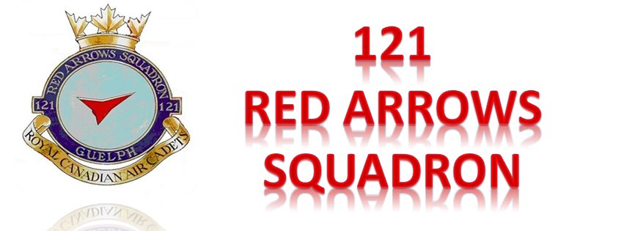

MERIT-BASED CADET PROMOTIONS

Adapted from CATO 13-02 (Nov 2013)

MERIT-BASED CADET RANK PROMOTIONS

DEFINITIONS

- For the purposes of this order, the following definitions will apply:

“Divisional Officer (Div O) / Platoon Commander (Pl Comd) / Flight Commander (Flt Comd) (Corps/Sqn)” any corps/sqn officer involved with leading and supervising cadets and delivering the cadet training program (note: this does not include the corps/sqn CO).

“Leadership Appointments” specific long-term practical leadership opportunities in which cadets are responsiblefor leading and mentoring an established team of cadets, outside their peer group, to accomplish a major duty / task. Examples include Divisional Petty Officer / Platoon Warrant Officer / Flight Sergeant, Supply NCO, Administration NCO, Training NCO, Canteen Steward, Drill Team Commander, Marksmanship Team Captain, etc.

“Leadership Assignments” specific short- and long-term practical leadership opportunities in which cadets are responsible for leading an assigned transient team of cadets, within or outside their peer group, to accomplish a minor or major duty / task. These Leadership Assignments are intended to be authentic and therefore are programmed to coincide with the naturally occurring leadership opportunities that exist during the conduct of most cadet activities.

“Promotion” the progression of a cadet from their current rank to one rank immediately higher.

“Transactional Leadership” focused on the knowledge and skills associated with “doing” leadership. Emphasis is placed on how to employ people and resources to get results. It is about accomplishing a specific duty / task (i.e. Leadership Assignments, conducting meetings, solving problems, etc)

“Transformational Leadership” focused on the knowledge and skills associated with “being” a leader. Emphasis is placed on how to bring about significant change in others by encouraging followers by acting as a role model, motivating through inspiration, stimulating intellectually, and giving individualized consideration for needs and goals. It is about helping others develop their leadership skills and realizing their leadership potential.

AUTHORITY

Corps/sqn Commanding Officers (COs) are the authority to promote cadets in their units unless the promotion requires an exception to policy. RCSU COs will be the authority when there is an exception to policy.

CORPS / SQUADRON RANK VACANCIES

The maximum number of vacancies for the rank of Warrant Officer First Class (WO1) is one per sqn. There is no limit to the number of cadets that can be promoted to the ranks of Leading Air Cadet (LAC) to Warrant Officer Second Class (WO2).

RANK PROMOTION CRITERIA
As illustrated at Annex A, rank promotion is a progression model directly linked to the Leadership
Team Model wherein cadets may be recognized for proficiency in the training program and awarded suitable advancement opportunities. Promotion is not automatic and a cadet may only be awarded one rank at a time.

Promotion to LAC

- participated in the first year of the proficiency level training program for a minimum period of five months, and
- recommended by the appropriate Flt Comd

Promotion to Corporal

- hold the rank of LAC,
- successfully completed year one of the proficiency level training program
- participated in the Cadet Fitness Assessment as part of PO X04 (Personal Fitness & Healthy Living), and
- recommended by the appropriate Flt Comd

Promotion to Flight Corporal

- completed at least six months of service at the rank of Cpl,
- successfully completed the second year of the proficiency level training program,
- participated in the Cadet Fitness Assessment as part of PO X04 (Personal Fitness & Healthy Living), and
- recommended by the appropriate Flt Comd

Promotion to Sergeant

- completed at least six months service at the rank of FCpl,
- successfully completed the third year of the proficiency level training program,
- achieved a minimum of “completed without difficulty” in PO 303 (Leadership),
- participated in the Cadet Fitness Assessment as part of PO X04 (Personal Fitness & Healthy Living), and
- recommended by the appropriate Flt Comd

Promotion to Flight Sergeant

- completed at least six months service at the rank of Sgt,
- successfully completed the fourth year of the proficiency level training program,
- achieved a minimum of “completed without difficulty” in PO 403 (Leadership),
- participated in the Cadet Fitness Assessment as part of PO X04 (Personal Fitness & Healthy Living), and
- recommended by the appropriate Flt Comd

Promotion to Warrant Officer 2nd Class
- completed at least six months service at the rank of PO1 / WO / FSgt,
- achieved a minimum of “completed without difficulty” in PO 503 (Leadership),
- participated in the Cadet Fitness Assessment as part of PO 504 (Personal Fitness & Healthy Living),
- recommended by the appropriate Flt Comd and
- identified as a successful candidate through the merit review board process

Promotion to Warrant Officer 1st Class

- completed at least six months service at the rank of WO2,
- recommended by the appropriate Flt Comd and
- identified as a successful candidate through the merit review board process

ADDITIONAL LEADERSHIP ATTIRBUTES

Additional leadership attributes that the Flt Comd needs to consider when recommending whether or not a cadet should be promoted include:

a. dress and deportment

b. conduct, discipline, and attitude

f. participation

g. response to direction

c. ability to interact positively and comfortably
with others

d. ability to make sound judgements regarding
their own actions

e. willingness to accept responsibility

h. ability to solve problems effectively

i. ability to communicate effectively

j. ability to set a positive example for others

k. initiative

