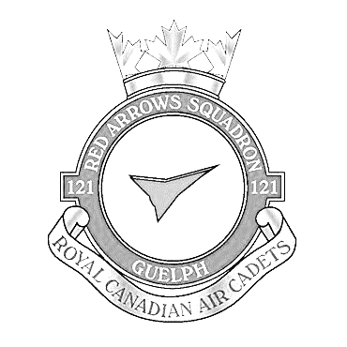
121 Red Arrows Name: __________________________
Royal Canadian Air Cadet Sqn
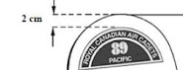
K Cleaners and Tailor Shop Ph#: ____________________________
519-824-9946
160 Kortright Rd W, Unit 4 Sewing:
Guelph, ON
Mon-Fri: 7-8 p.m.
Sat: 8:30-5:30 p.m.
Sun: 12-4 p.m.
*This form is to be affixed to the Tunic for tracking purposes
Monthly billing is to 121 Red Arrows Royal Canadian Air Cadet Squadron
7 Wyndham Street South, Guelph, ON N1H 4C4
Contact Officer: Captain Scott Stuart
*DETACH BELOW – PROVIDE UPPER PORTION TO K CLEANERS
- - - - - - - - - - - - - - - - - - - - - - - - - - - - - - - - - - - - - - - - - - - - - - - - - - - - - - - - - - - - - - - - - - - - - - - - c u t - - - -

Cadet Name: _____________________________________

Flight Number: _____________________________________

Level: _____________________________________

New Issue?: YES / NO
Repair? YES / NO (ensure shoulder flashes are removed)
*if shoulder flashes were improperly sewn on, prior authorization from Flight Officer must be received

Name of Flight Officer Approving Repair: ______________________________________

Note: ONLY X2 shoulder flashes are authorized to be billed to the Squadron at No Charge to the cadet (monthly billing)
All other badges must be paid for by the cadet/family
RETURN THIS PORTION OF FORM TO SUPPLY ONCE SHOULDER FLASHES ARE SEWN ON

